**Merke:**

**Abercrombie & Fitch**

Abercrombie & Fitch

**Adidas**

Adidas”,”Adidas Orgininals

**Alpha Industries**

Alpha Industries

**Calvin Klein**

Calvin Klein”,”Calvin Klein Jeans

**Crocs**

Crocs

**Emporio Armani**

Armani”,”Armani Exchange”,”EA7 Emporio Armani”,”Emporio Armani

**Eton**

Eton

**Gant**

Gant

**Hackett London**

Hackett London

**Hugo Boss**

Boss Casual”,”Hugo”,”Hugo Boss

**Les Deux**

Les Deux

**Nike**

Nike”,”Nike Sportswear

**Polo Ralph Lauren**

Polo Ralph Lauren”,”Ralph Lauren

**Tiger of Sweden**

Tiger of Sweden

**Tommy Hilfiger**

Tommy Hilfiger”,”Tommy Jeans

**Vans**

Vans

**Versace**

Versace”,”Versace Jeans”,”Versace Collection

**Yourturn**

Yourturn

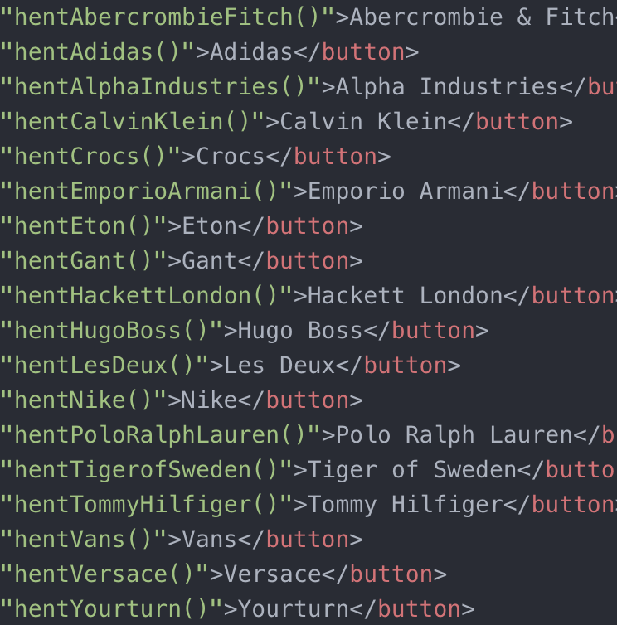

**Overmateriale:**

Bomull

Dun

Elastan

Fjær

Imitert skinn

Kunststoff

Lær

Nylon

Plastikk

Polyamid

Polyester

Polyuretan

Rustfritt stål

Skinn

Suede

Syntetisk materiale

Tekstil

Viskose

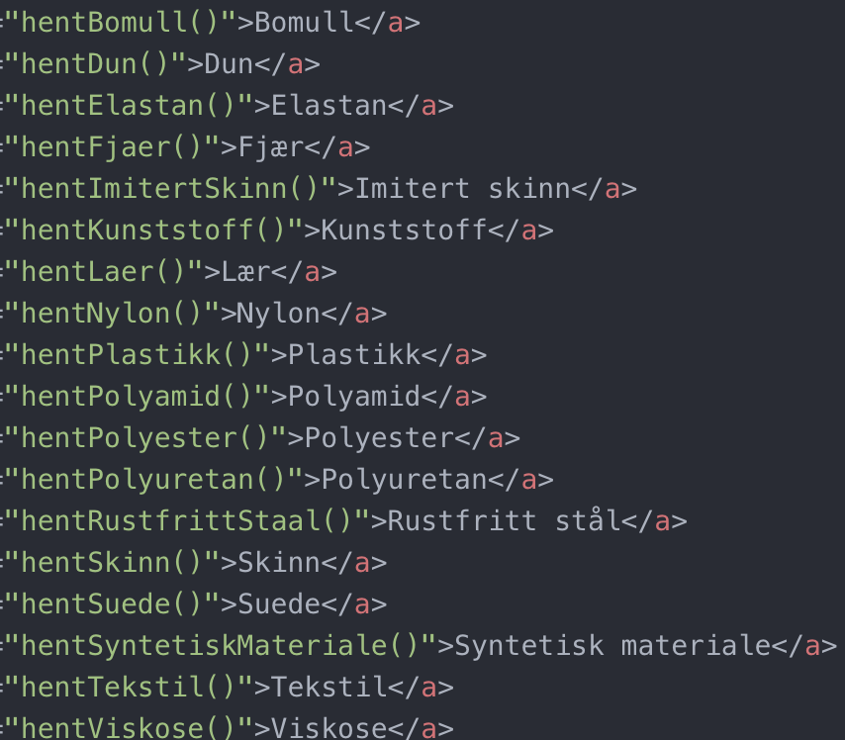

**Størrelse (Klær):**

Onesize

XS

S

M

L

XL

XXL

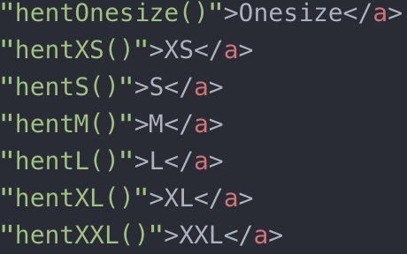

**Størrelse (Sko):**

36

37

38

39

40

41

42

43

44

45

46

47

48

49

50

51

52

53

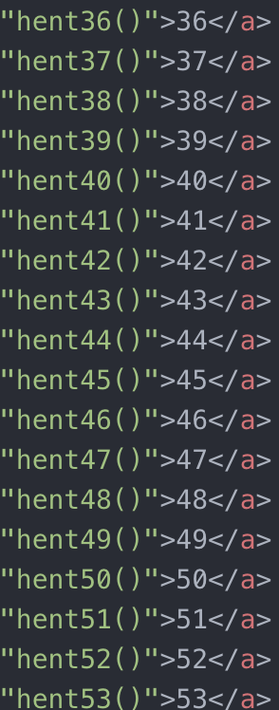

**Farge:**

**Blå**

Aviator Navy”,”Bermuda Blue”,”Black/Blue”,”Blau”,”Blue”,”Blue Jeans”,”Blue Tones”,”Blue/White”,”Capri Blue”,”Cruise Navy”,”Dark Blue”,”Dark Blue/Blue/Light Blue”,”Dark Blue/Bordeaux”,”Dark Blue/Red”,”Dark Blue/White/Red”,”Deep Blue Heather”,”Deep Royal Blue/Hyper Jade/Black”,”Deep Royal Blue/Orange Peel/White”,”Evening Blue”,”French Navy”,”Hammond Blue”,”Hunter Navy”,”Lapies Blue/Flame Orange”,”Light Blue”,”Light/Pastel Blue”,”Navy”,”Navy Blazer”,”Navy Heather”,”Navy/Chalk”,”New Navy”,”Newport Navy”,”Open Blue”,”Orange/Hellgrün/Hellblau”,”Peacoat”,”Rep Blue”,”Weiss/Blau/Rot”,”White/Blue”,”White/Heather Gray/Navy Blue”,”White/Multicoloured”,”White/Red/Blue

**Brun**

Beige”,”Boating Khaki”,”Brown”,”Brown/Gold”,”Chocolate”,”Khaki”,”Light/Pastel Brown”,”Open Beige”,”Snuff”,”White/Multicoloured

**Grønn**

Army Green”,”Black/Green”,”Dark Green”,”Dark Oliv”,”Deep Lichen Green”,”Deep Royal Blue/Hyper Jade/Black”,”Evergreen”,”Fawn Green”,”Grass Green”,”Green”,”Oil Green”,”Olive”,”Orange/Hellgrün/Hellblau”,”Petrol”,”Scotch Pine Heath”,”Supply Olive”,”Trace Cargo/Solar Yellow

**Grå**

Andover Heather”,”Anthracite”,”Anthracite/Black/Metallic Silver”,”Anthrazit”,”Black/Anthracite”,”Black/Grey”,”Dark Grey”,”Fawn Grey Heather”,”Grey”,”Grey Four/Shock Red”,”Grey Heather”,”Light Grey Melange”,”Open Grey”,”Slate Grey”,”White/Infrared 23/Wolf Grey/Black

**Gul**

Fall Yellow”,”Oatmeal Heather”,”Trace Cargo/Solar Yellow”,”Wheat/Black/Club Gold

**Gull**

Brown/Gold”,”Team Orange/University Gold/Black”,”Wheat/Black/Club Gold

**Hvit**

Andover Heather/Black/White”,”Black/White”,”Blue/White”,”Bright White”,”Dark Blue/White/Red”,”Deep Royal Blue/Orange Peel/White”,”Eggshell”,”Grau/Weiss/Schwarz”,”Grey Heather/White”,”Navy/Chalk”,”Nero/Bianco”,”Offwhite/Obsidian/University Red”,”Open White”,”Sail/White/Black”,”Snow Melange”,”Weiss”,”Weiss/Blau/Rot”,”White”,”White/Black”,”White/Blue”,”White/Heather Gray/Navy Blue”,”White/Heather/Black”,”White/Infrared 23/Wolf Grey/Black”,”White/Multicoloured”,”White/Red/Black”,”White/Red/Blue

**Lilla**

Pastel Purple

**Oransje**

Alpha Orange”,”Deep Royal Blue/Orange Peel/White”,”Lapies Blue/Flame Orange”,”Orange/Hellgrün/Hellblau”,”Sailing Orange”,”Team Orange/University Gold/Black”,”Wheat/Black/Club Gold

**Rosa**

Light Pink”,”Pink”,”Rose”,”Silver/Pink”,”Taylor Orange

**Rød**

Black/Red”,”Burgundy”,”Dark Blue/Bordeaux”,”Dark Blue/Red”,”Dark Blue/White/Red”,”Dark Red”,”Deep Maroon”,”Garnet”,”Grey Four/Shock Red”,”Martin Red”,”Offwhite/Obsidian/University Red”,”Red”,”Weiss/Blau/Rot”,”White/Infrared 23/Wolf Grey/Black”,”White/Multicoloured”,”White/Red/Black”,”White/Red/Blue

**Svart**

Andover Heather/Black/White”,”Anthracite/Black/Metallic Silver”,”Black”,”Black Camo”,”Black Copper”,”Black/Anthracite”,”Black/Black”,”Black/Blue”,”Black/Green”,”Black/Grey”,”Black/Red”,”Black/Silver”,”Black/White”,”CK Black”,”Deep Royal Blue/Hyper Jade/Black”,”Grau/Weiss/Schwarz”,”Grey/Black”,”Nero/Bianco”,”Nero/Oro”,”Night Sky”,”Offwhite/Obsidian/University Red”,”Sail/White/Black”,”Schwarz”,”Team Orange/University Gold/Black”,”Wheat/Black/Club Gold”,”White/Black”,”White/Heather/Black”,”White/Infrared 23/Wolf Grey/Black”,”White/Red/Black

**Sølv**

Anthracite/Black/Metallic Silver”,”Black/Silver”,”Silver/Pink

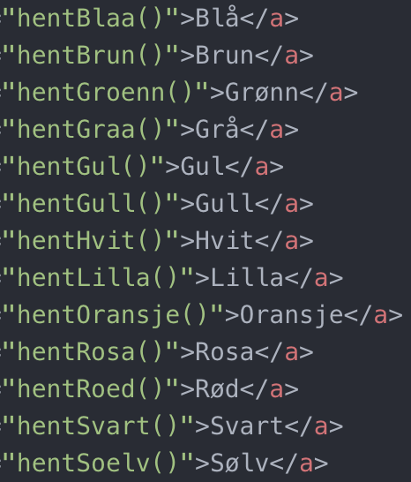

**Pris:**

≥199

200-399

400-599

600-799

800-999

1000-1199

1200-1399

1400-1599

1600-1799

1800-1999

2000-2499

2500-2999

3000≤

